Worksheet Arithmetic Mean
- The following are the number of math books issued in a school library during a week: 222, 120, 201, 322, 167, 273, 406 and 345. Find the average number of math books issued per day.
- If the arithmetic mean of 7, 9, 11, 13, x, 21 is 13, find the value of x.
- The mean weight of 8 girls in a group is 35 kg. The individual weights of seven of them are 35 kg, 28 kg, 43 kg, 25 kg, 33 kg, 51 kg and 22 kg. Find the weight of the eighth girl.
- If the arithmetic mean of 2m+3, m+2, 3m+4, 4m+5 is m+2, find m.
- The mean monthly salary of 10 workers of a group is ₹1445. One more worker whose monthly salary is ₹1500 has joined the group. Find the arithmetic mean of the monthly salary of 11 workers of the group.
- Calculate the Arithmetic mean of the following data by direct method
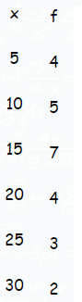
- Calculate Arithmetic Mean for the following discrete data −
Items | 14 | 36 | 45 | 70
Frequency | 2 | 5 | 1 | 3
- The following data shows the weekly income of 10 families.

Family | A | B | C | D | E | F | G | H | I | J
Weekly Income (in Rs) | 850 | 700 | 100 | 750 | 5000 | 80 | 420 | 2500 | 400 | 360
Compute the mean family income.
- Given the following frequency distribution, calculate the arithmetic mean and median
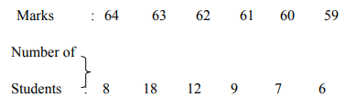
- The following data gives the weekly wages (in `) of 20 workers in a factory:
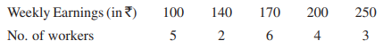
Calculate the average weekly earnings of the workers.

